Multithreading:
Multithreading is a process of executing two or more parts of a program simultaneously to maximum utilization of the CPU. Each part of such a program is called a thread.

Synchronization:
In Java, synchronization is the mechanism that controls the access of multiple threads to shared resources. Without it, you might encounter "Race Conditions," where two threads modify the same data simultaneously, leading to unpredictable results.
Think of it like a single-person restroom: the lock on the door ensures that only one person can enter at a time. In Java, this "lock" is known as a Monitor.
Race Condition:
Race Condition ek aisi situation hai jaha do ya do se zyada threads ek hi shared data par kaam karne ki koshish karte hain, aur final result is baat par depend karta hai ki kaunsa thread pehle execute hua.
Isse program mein unpredictable bugs aate hain kyunki result hamesha "race" (kaun jeeta) par nirbhar karta hai.

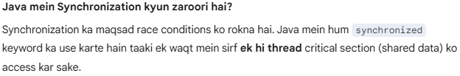
Method Level Synchronization:
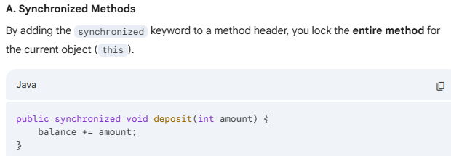
Block Level Synchronization:
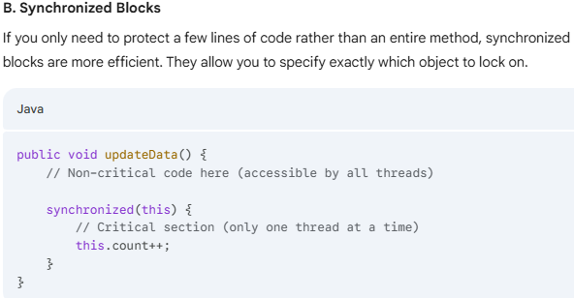

Volatile keyword:
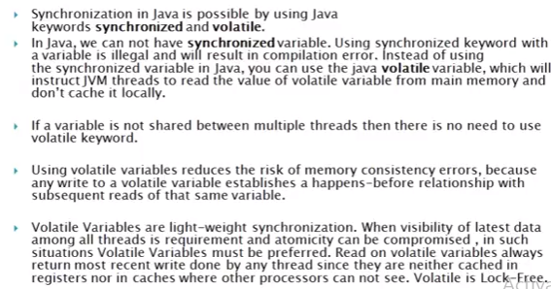

Note: In volatile first priority is to always write after read operation.
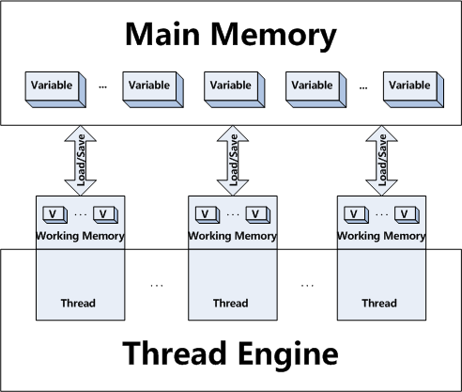

Differences Between Synchronized and Volatile:
1. The volatile keyword in Java is a field modifier while synchronized modifies code blocks and methods.
2. Synchronized obtains and releases the lock on monitor’s Java volatile keyword doesn't require that.
3. Threads in Java can be blocked for waiting for any monitor in case of synchronized, that is not the case with the volatile keyword in Java.
4. Synchronized method affects performance more than a volatile keyword in Java.
5. Since volatile keyword in Java only synchronizes the value of one variable between Thread memory and "main" memory while synchronized synchronizes the value of all variable between thread memory and "main" memory and locks and releases a monitor to boot. Due to this reason synchronized keyword in Java is likely to have more overhead than volatile.
6. You can not synchronize on the null object but your volatile variable in Java could be null.
7. From Java 5 writing into a volatile field has the same memory effect as a monitor release, and reading from a volatile field has the same memory effect as a monitor acquire
Example Singleton Class in case of Multithreading:
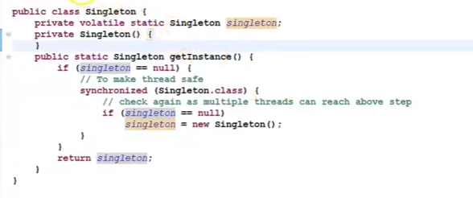
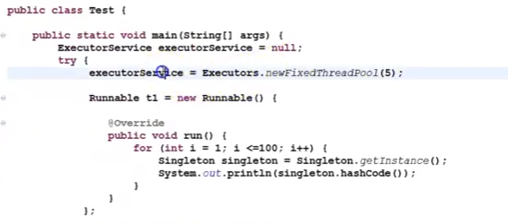
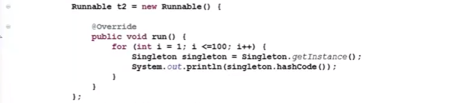
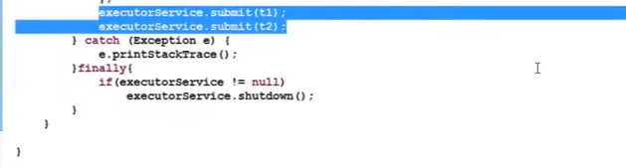
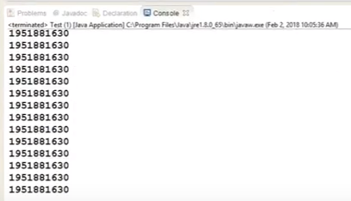
The hashcode will be the same because instance create only once.
Note: Volatile gives a visibility but not the atomicity.

Atomic Variable:
Atomic variables are classes provided in the java.util.concurrent.atomic package that allow you to perform thread-safe operations on single variables without using locks (like synchronized or ReentrantLock).
Example-#1
Problem:
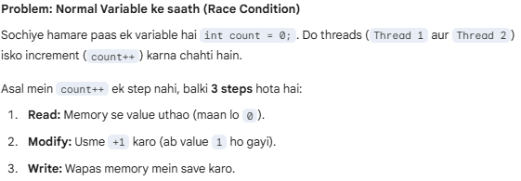
Solution:
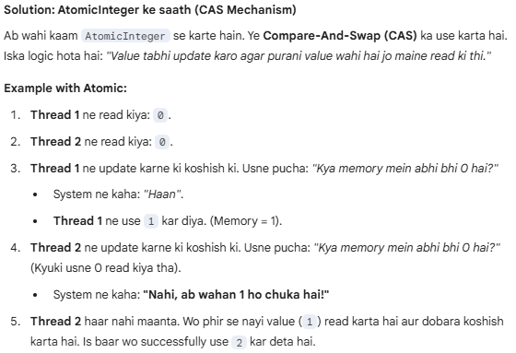
AtomicInteger
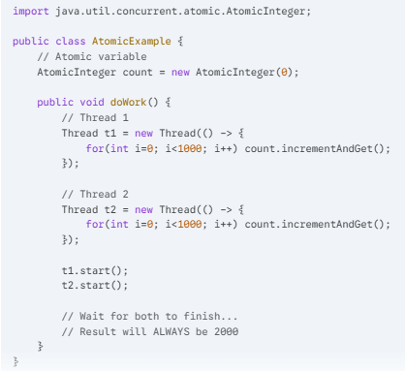

Thread Pool:
Most of the executor implementations use thread pools to execute tasks, A thread pool is nothing but a bunch of worker threads that exist separately from the runnable or Callable tasks and is managed by the executor.
Creating a thread is an expensive operation and it should be minimized. Having worker threads minimizes the overhead due to thread creation because executor service has to create the thread pool only once and then it can reuse the threads for executing any tasks.
Tasks are submitted to a thread pool via an internal queue called the Blocking queue. If there are more tasks then for waiting until any thread becomes available. If the blocking queue is full than new tasks are rejected
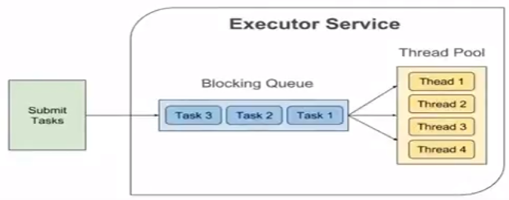

java.util.concurrent:
The java.util.concurrent (J.U.C) package is organized into several distinct sub-hierarchies. Rather than one single tree, it is a collection of frameworks designed to handle specific threading problems like task scheduling, synchronization, and thread-safe data storage.
It was introduced in JDK 1.5 release as an alternative of synchronized keyword. As I told you Lock is an interface, so we cannot use it directly, instead we need to use its implementation class

Future and Callable Concurrency:
java.util.concurrent.Callable object can return the computed result done by a thread in contrast to runnable interface which can only run the thread. The Callable object returns Future object which provides methods to monitor the progress of a task being executed by a thread. Future object can be used to check the status of a Callable and then retrieve the result from the Callable once the thread is done. It also provides timeout functionality.
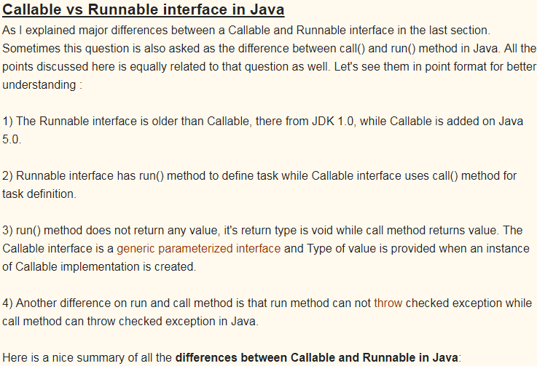


Both callable and runnable interface are the Functional Interface(annotation of the java 7(functionalinteface)).
Runnable interfaces belong to java.lang package.
- In this runnable run method don’t throws any exception.
- Does not return any value.
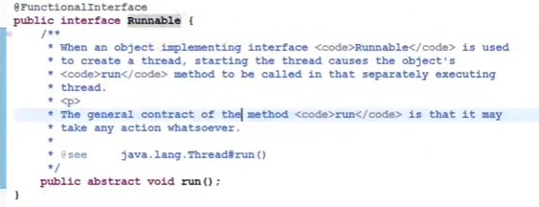
Callable interface belong to java.util.concurrent. package.
- In this callable call() method throws Exeption.
- It return future value means return object.
- Return type “v” represent Future Interace.


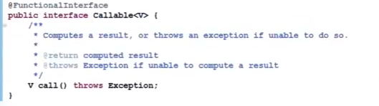
Example:

Output: Future Result : My Callable Interface Task

1. The Executor Framework (Task Execution):
Managing thread pools and asynchronous tasks. It separates task submission from task execution.
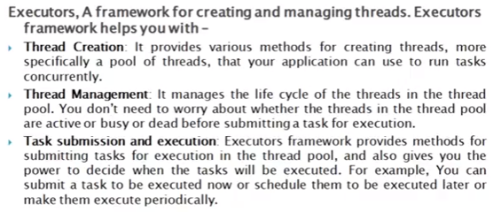
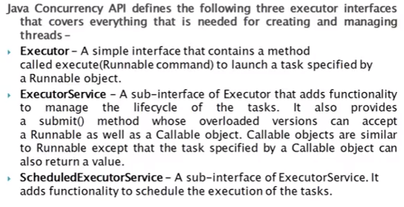

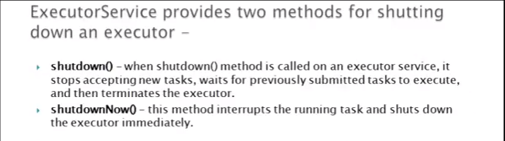

2.Executor Interface:
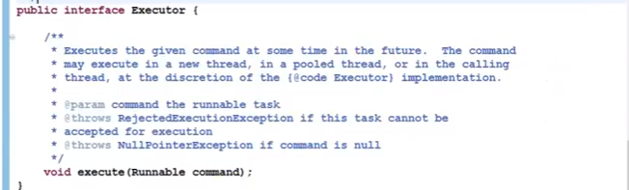

3.ExecutorService Interface:
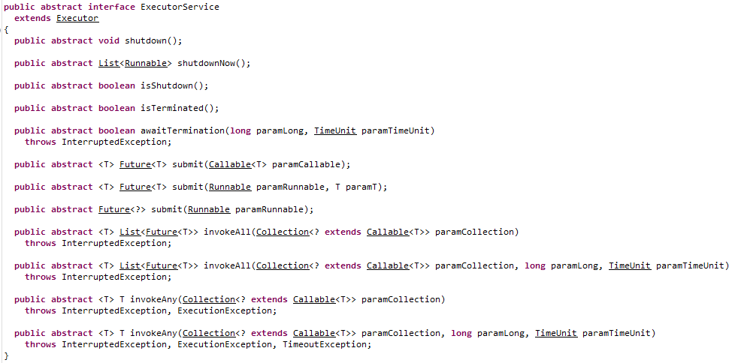
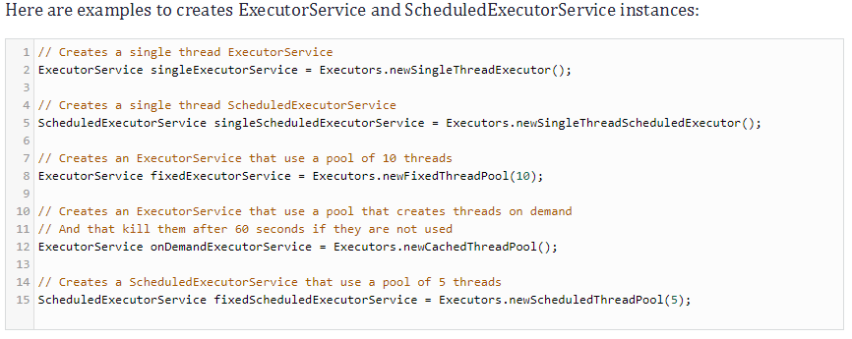

4.ScheduledExecutorService Interface:
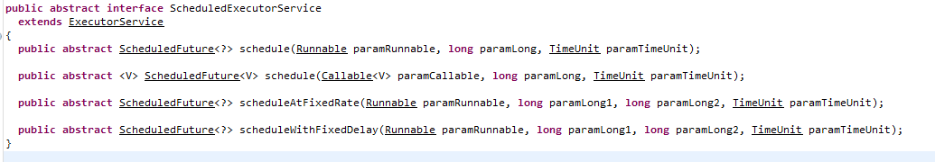

Executors Utility Class:
Apart from the above three interfaces, the API also provides an Executors class that contains factory methods for creating different kinds of executor services.
Example #1.
Store all threads into the thread pool.
Here we are using single thread only. So it will create single thread only into the thread pool.
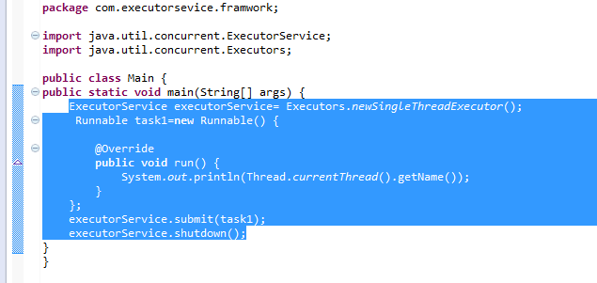
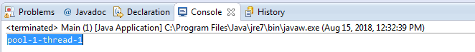
Example #2:
Java ExecutorService with a pool of threads for executing multiple tasks:
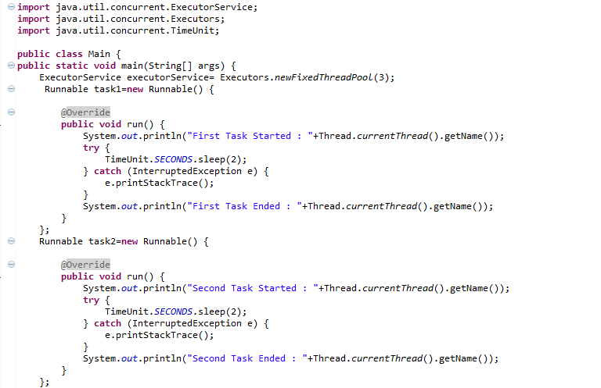
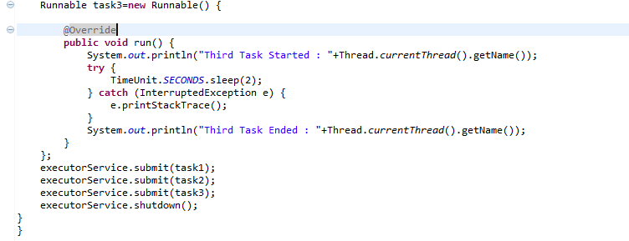
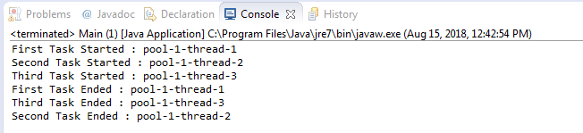

Java Concurrency - Lock Interface:
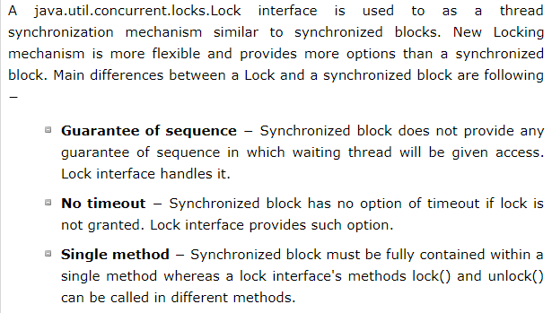
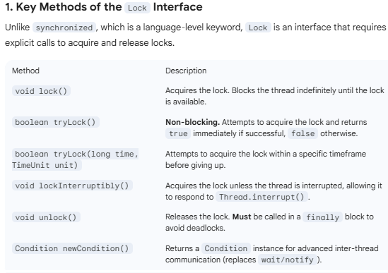

ReentrantLock
ReentrantLock is the most common implementation. "Reentrant" means a thread can re-acquire the same lock it already holds without deadlocking itself (it simply increments a "hold count").
A ReentrantLock is a concrete implementation of the Lock interface in the java.util.concurrent.locks package. It is called "reentrant" because it allows a thread to acquire the same lock multiple times without deadlocking itself.
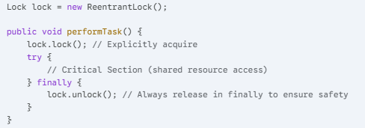
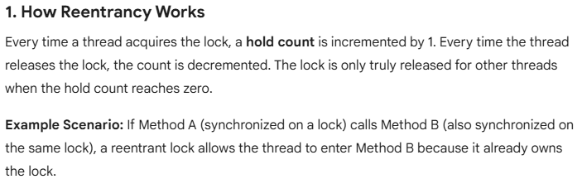
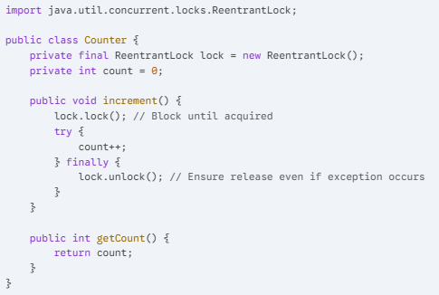

Blocking Queues (Data Transfer):
Before BlockingQueue, you had to manually use synchronized, wait(), and notifyAll() to manage buffers, which is extremely error-prone and leads to bugs like Lost Wakeups or Spurious Wakeups. BlockingQueue encapsulates all that complexity into a single, thread-safe class.
Blocking Queues are the primary tool for solving the Producer-Consumer problem. They act as a thread-safe "buffer" that handles the coordination of data transfer between threads automatically.
What makes them "Blocking" is their behavior when the queue is full or empty:
- When Empty: A thread trying to take() an element will block (wait) until a producer adds something.
- When Full: A thread trying to put() an element will block (wait) until a consumer removes something (for bounded queues).
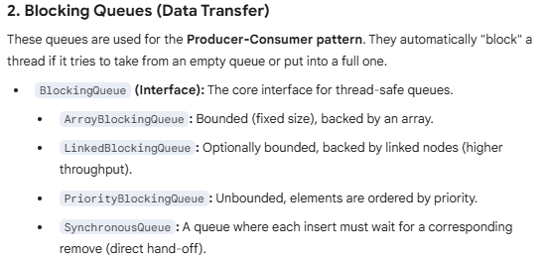

Synchronizers:
Synchronizers are high-level coordination utilities that facilitate common interaction patterns between threads. They allow threads to wait for each other, communicate state changes, or manage access to shared resources without the complexity of low-level wait() and notify() calls.
Here is the breakdown of the primary synchronizers found in java.util.concurrent.

1.CountDownLatch:
Real-life example aisa samajhiye: Ek race tabhi start hogi jab saare (N) runners starting line par pahunch jayenge.
CountDownLatch in Java is a kind of synchronizer which allows one Thread to wait for one or more Threads before starts processing. This is very crucial requirement and often needed in server side core Java application and having this functionality built-in as CountDownLatch greatly simplifies the development. CountDownLatch in Java is introduced on Java 5.
When should we use CountDownLatch in Java :
Use CountDownLatch when one of Thread like main thread, require to wait for one or more thread to complete, before its start doing processing. Classical example of using CountDownLatch in Java is any server side core Java application which uses services architecture, where multiple services is provided by multiple threads and application cannot start processing until all services have started successfully as shown in our CountDownLatch example.countDownLatch in Java – Things to remember:
Few points about Java CountDownLatch which is worth remembering:
1. You can not reuse CountDownLatch once count is reaches to zero, this is the main difference between CountDownLatch and CyclicBarrier, which is frequently asked in core Java interviews and multi-threading interviews.
2. Main Thread wait on Latch by calling CountDownLatch.await() method while other thread calls CountDownLatch.countDown() to inform that they have completed.
Example: IT and BA task.
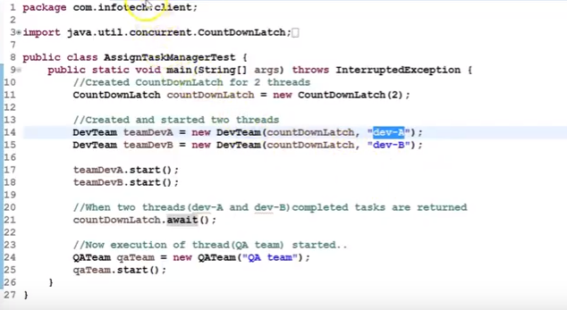
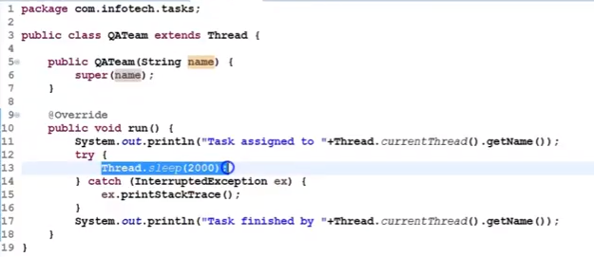
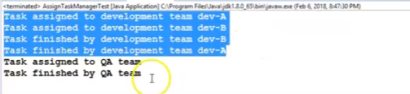

2.CyclicBarrier:
CyclicBarrier in Java is a synchronizer introduced in JDK 5 on java.util.Concurrent package along with other concurrent utility like Counting Semaphore, BlockingQueue, ConcurrentHashMap etc. CyclicBarrier is similar to CountDownLatch and allows multiple threads to wait for each other (barrier) before proceeding. The difference between CountDownLatch . CyclicBarrier is a natural requirement for a concurrent program because it can be used to perform final part of the task once individual tasks are completed. All threads which wait for each other to reach barrier are called parties, CyclicBarrier is initialized with a number of parties to wait and threads wait for each other by calling CyclicBarrier.await() method which is a blocking method in Java and blocks until all Thread or parties call await(). In general calling await() is shout out that Thread is waiting on the barrier. await() is a blocking call but can be timed out or Interrupted by other thread.
Difference between CountDownLatch and CyclicBarrier in Java:
If you look at CyclicBarrier it also the does the same thing but there is different you can not reuse CountDownLatch once the count reaches zero while you can reuse CyclicBarrier by calling reset() method which resets Barrier to its initial State. What it implies that CountDownLatch is a good for one-time events like application start-up time and CyclicBarrier can be used to in case of the recurrent event e.g. concurrently calculating a solution of the big problem etc.
Important point of CyclicBarrier in Java:
1. CyclicBarrier can perform a completion task once all thread reaches to the barrier, This can be provided while creating CyclicBarrier.
2. If CyclicBarrier is initialized with 3 parties means 3 thread needs to call await method to break the barrier.
3. The thread will block on await() until all parties reach to the barrier, another thread interrupt or await timed out.
4. If another thread interrupts the thread which is waiting on barrier it will throw BrokernBarrierException as shown below:
java.util.concurrent.BrokenBarrierException
at java.util.concurrent.CyclicBarrier.dowait(CyclicBarrier.java:172)
at java.util.concurrent.CyclicBarrier.await(CyclicBarrier.java:327)
5.CyclicBarrier.reset() put Barrier on its initial state, other thread which is waiting or not yet reached barrier will terminate with java.util.concurrent.BrokenBarrierException.
Example:
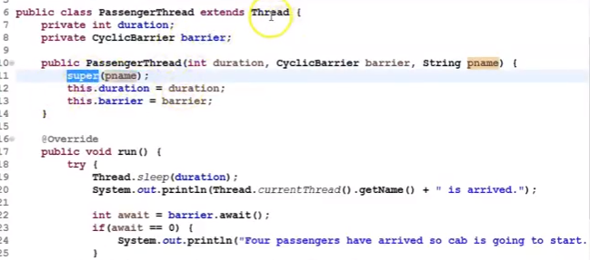

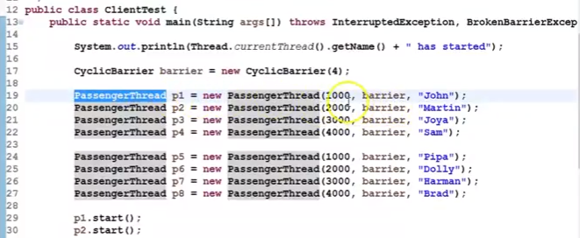

} }
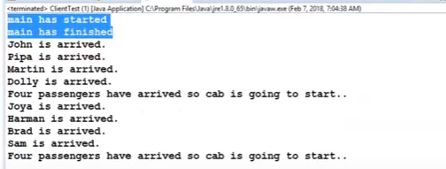

3. Semaphore:
Semaphore multithreading mein ek aisi utility hai jo "Permits" (Ijazat/Tokens) ke concept par kaam karti hai. Iska asali maqsad ye control karna hota hai ki ek waqt mein kitne threads kisi specific resource (jaise Database connection, File, ya Network socket) ko access kar sakte hain.
Ise aap ek Parking Lot ki tarah samajh sakte hain:
- Agar parking mein 10 jagah (permits) hain, toh 10 gaadiyan (threads) andar ja sakti hain.
- 11वीं gaadi ko tab tak bahar wait karna padega jab tak koi ek gaadi nikal na jaye.
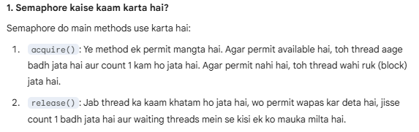
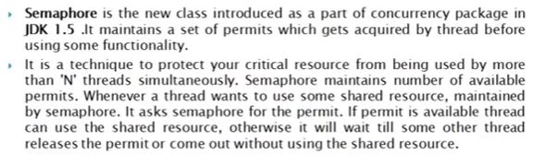
Example:
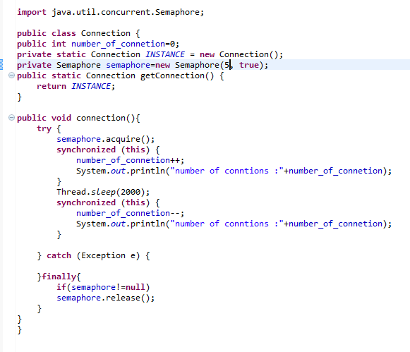
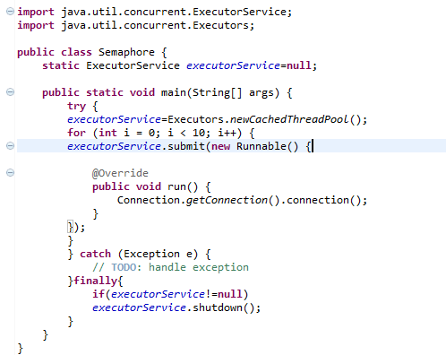
Before Semaphore implement it will create number of connections that we are using in loop(50)
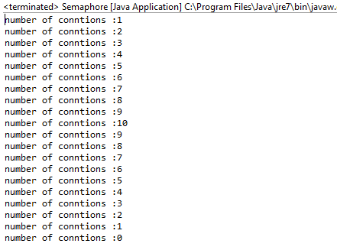
After Semaphore Implement: it will create only connection pool.
